
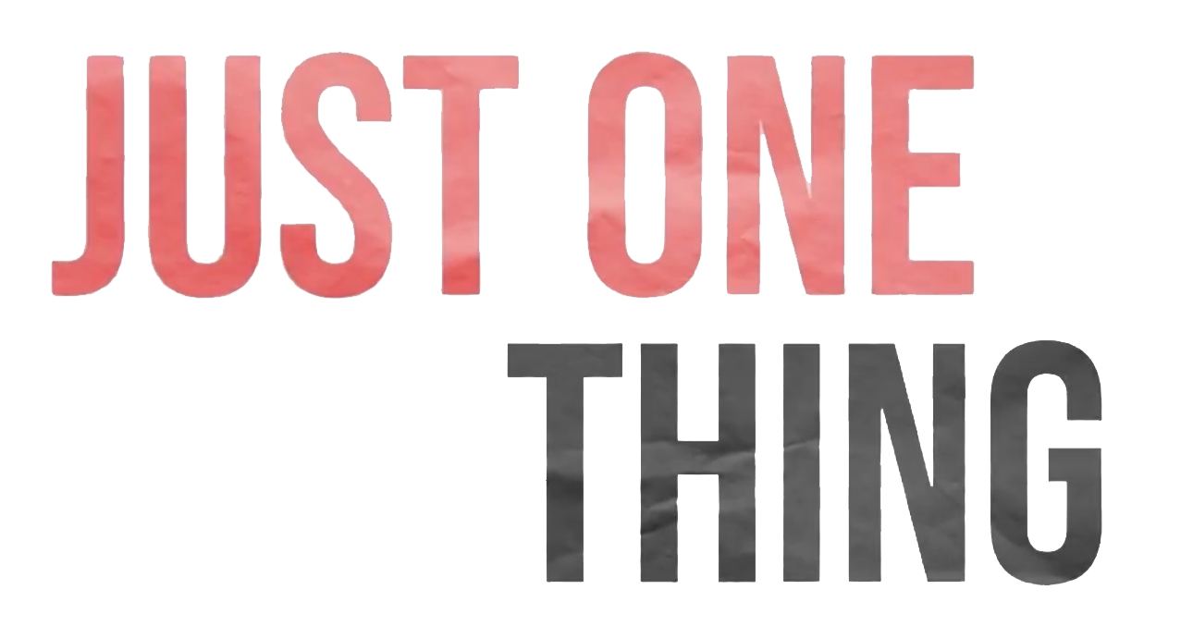
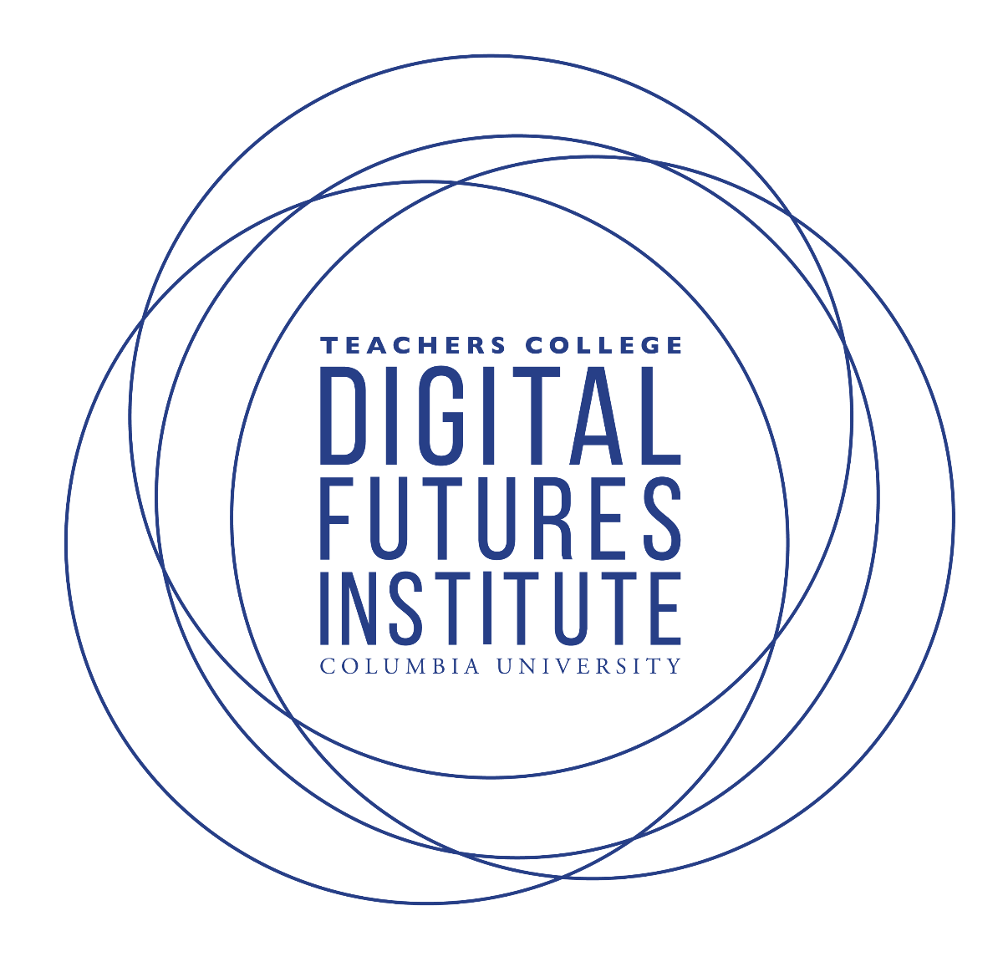
Before Class Prep |

Cue up videos, or have students watch a Just One Thing episode (or a few). By watching a few videos in the series students will have the opportunity to see different ideas and approaches to J1T production.

Part of the philosophy of Just One Thing’s production was flexibility with creators. In keeping with this, we suggest allowing students to either come with an idea or brainstorm in a group.

Video Discussion
Introduction & Discussion |

- Discuss both the method and content of the video(s)
  - What visuals stuck out to you and why? Do you think this is what the producers intended?

  - What do you think was important for the creators?

Your Just One Thing
What is important to you?

- Why is this important for you?

- Why is this important for others to hear about?

How are you going to say it?

- What format would you like to utilize?

- What feeling or tone would you like to work towards?

- Where, when, and why?
  - Pick who you want to talk to? Why?
  - Where you will go?
  - Who will be your main narrator?
  - What are the most interesting points of your topic?
  - Who is your audience?
  - What information/exposition do you need to tell your audience?

| Visuals

What visuals do you have in mind that will assist in communicating your idea?

Visual idea description  (draw or write what a moment in you would like to convey in your Just One Thing video) | Source ideas  (try to find a similar depiction of what you have in mind) | Medium  (still image, text, animation, moving image ect.) | Make a plan B of a second way you can present your visual

Representation and Depiction |

How would you represent your Just One Thing on different platforms? What would be the possibilities and constraints that each setting would offer?
Platform | Possibilities | Constraints
With a friend through conversation
YouTube
Twitter
Instagram
TikTok

Notes:

