Learning with the Assistance of a Reflective Agent

Xin Bai John B. Black Jonathan Vitale
Teachers College, Columbia University
525 West 120th Street, Box 8
New York, NY 10027 U.S.A.
Email: xb4@columbia.edu;black@exchange.tc.columbia.edu;jonvitale@gmail.com

Abstract: This paper describes the development of a simulation game, REAL Business, using an agent-based approach. REAL Business is based upon our cognitive framework REAL (reflective agent learning environment), which incorporates research on ICAI, agent technologies, and cognition in educational simulation games. Students teach the reflective agent how the system should work based upon what they know. The reflective agent takes the full control in the game, generating a sequence of behaviors analogous to those generated by the users’ mind. Entities in simulation are also autonomous agents. Each agent uses its own ontology that is either built-in or constructed by users. Users observe the consequence of their teaching with visual tools that display statistical data about the world. Our study shows that this learning environment promotes reflective thinking, motivates learners, and encourages collaboration among researchers in its quick turn-around time of prototyping.

- Introduction

We need a mirror to reflect upon our appearance. A reflective agent is like a mirror, externalizing our internal mental world. Advances in agent technology as well as research on human cognition provide opportunities for researchers to develop agents that can represent what we think in a simulated world, thus giving us opportunities to engage in meta-cognitive learning processes.
In this study users are modeled by having them explicitly externalize their internal knowledge representations and apply them in a simulation game, which will generate a sequence of behaviors analogous to those generated by the users’ mind. The explicit expression of generalization is the essential meta-cognitive skill that can help learners make predictions and generate explanations of future problems in the real world. To win the game in REAL Business, users have to pass several game levels. A different community is loaded in each game level. This requires users to apply production rules to a generic environment that go beyond a specific system configuration. They will see a need to express their ideas using abstract formulas instead of specific statistics data.
Malone [13] suggested, rather than creating intelligent agents whose operations are “black boxes”, designers should try to create “glass boxes” where the essential elements of the agents’ reasoning can be seen and modified by learners. Knowledge in the symbolic level is easy to represent and implement in this kind of transparent systems. Theories like propositional representations [11, 5], schema [16], and semantic network [8] are examples of using symbols to represent cognitive knowledge in computing systems. But thinking is more than the manipulation of symbols by rules. Arthur [10] claims that meaning requires going beyond amodal, abstract and arbitrary (AAA) symbols. Barsalou [6] demonstrated that variability in the features listed for a concept and variability in the order in which features are listed are controlled by the perceptual simulation being engaged rather than by an abstract, unchanging semantic representation. Therefore, we need a generic constructive learning environment where uses are able to construct correct mental models through manipulating objects and events in simulations as well as interacting with knowledge in the symbolic level.
The agent technologies now allow us to embody objects with Belief-Desire-Intention (BDI) [7], hence giving those otherwise abstract symbolic objects human or animal-like decision-making abilities. These agents are empowered with their own thread of control. They are able to initiate actions in order to achieve goals, thus being able to interact autonomously in an environment. The intelligent agent paradigm makes it a perfect candidate for modeling users and developing dynamic emergent systems. Next, we will describe other prior research that has informed this study.
Learning by teaching is one of the successful approaches that encourage reflection on one’s own thinking processes. It involves experiencing understanding of oneself as a learner in a variety of contexts; organizing, monitoring, and evaluating one’s performance to derive a renewed state of understanding about one’s learning [17]. Betty’s Brain [3] is good example of applying the paradigm of learning by teaching. In Betty’s Brain, concept maps are used to represent knowledge. A concept map consists of objects and relations among those objects. According to Black [5], propositional networks are sets of entities illustrated by their interrelated relations and properties. It is similar to concept map in that they both represent knowledge structures and contents in a declarative way. The causal relations in concept map can also be represented as a series of condition-action or if-then rules. This is consistent with what Anderson [1] claimed in the ACT theory that “procedural knowledge could be obtained by making inferences from the declarative knowledge that deal with factual information”. However, these production rules derived from concept maps can only represent simple causal relations qualitatively. It’s hard to use concept map to model more complex procedural knowledge in a quantitative manner, such as, “if temperature is below 32° F, then fish do not move or eat; if temperature is above 32° F and shrimps are not enough, then fish eat plants, instead of shrimps”. It is these complex reasoning processes that allow users to predict event, reason about the complex mechanism, make valid explanation and prepare for solving problems in the real situation. Therefore, it would be beneficial if students could have tools to develop and teach an agent production rules, which could be applied to a set of propositional nodes.
Once concepts and rules about a system are defined, learners need a way to see consequences of activities associated with the knowledge. Simulation games are great candidates for running users’ imaginary world (i.e., mental model) [4]. “Running” of a mental model occurs when autonomous objects change states, thus influencing other autonomous objects [18]. According to Black [5], mental model, together with mental images, propositional networks and production rules are the four types of knowledge representation in human cognition.
In REAL, we attempted to develop such an integrated learning environment where users are motivated to teach a reflective agent with knowledge representations we mentioned above.
Modeling domain knowledge and developing simulation games are often time-consuming. We need to design a system that allows developers to model a subject domain and the corresponding simulation environment with a quick turn-around time, thus making it a practical platform for researchers to embed their ideas, and test out their hypothesis.
We adopted the rule-based approach to implement the rational agents that are capable of thinking and reasoning. These rule-based systems can efficiently model users in terms of working memory, goals, activation level, and procedural skills. These systems are very simple to implement and understand, which makes them easy to extend and customize. A rule-based system consists of facts, rules, and an engine that acts on them. Facts can present objects and their properties in propositional networks; rules can represent product systems. JESS (Java Expert System Shell) has become increasingly popular as a rule-based engine due to its stable performance and its native support to the Java programming language. Java objects can be represented as shadow facts in a JESS-based system [9]. These shadow facts are observable objects that can be modified by rules in the rule-based system. Its corresponding objects can be reached through procedure calls from the java system. Systems with such a design benefit from blending the powerful pattern matching system of JESS with the plethora of resources built into the Java system
Agents in a simulation games maintain their own thread that allows them to move around, detect collisions and make decisions. Game engines like Genuts [14] provide components that enable simplified, rapid development of games like this. Agents can be represented visually by sprites in Genuts, whose appearance, movement, and interaction is monitored by a field manager in Genuts. Genuts is also used to handle some of the feedback to the user in the form of thought bubbles above the character sprites. Rules defined in JESS can function as a “brain” that checks the status of these sprites and provides this information to the Genuts field manager. In this sense, sprites in Genuts games are simply passive receivers of instructions from the rule-based system.
Next we will describe the REAL cognitive architecture, and an implementation, REAL Business, which serves as a prototype for embedding autonomous reflective agent in a simulation gaming environment.

- The REAL framework

REAL provides an interactive learning environment that allows students to 1) construct their imaginary world; 2) reflect upon the quality of their understanding; 3) test it out in the dynamically generated simulation games. Learners develop knowledge and skills in the process of constructing their understanding of the subject domain, and observing behaviors and consequences in the simulation games as a result of their design.
The REAL cognitive framework benefits from prior research on Intelligent Agents, ICAI, artificial intelligence, cognitive science and educational games. Its cognitive architecture extends the traditional ICAI architecture, which consists of expert module, pedagogical module, and user model. REAL consists of the following components:
Reflective agent – This agent is the student model which stores specific information about individual learners. It models students’ level of competence and contains information to be used by the pedagogical agent of the system. Similar to the expert agent, it contains declarative and procedural knowledge, as well as imagery representations of the world. Once constructed, the reflective agent can be released in the simulation gaming environment for the students to observe. The reflective agent’s behaviors represent those that run in the student’s imaginary world [5]. What the reflective agent can do in the simulation is constrained by system mechanism implemented in the expert agent. For instance, a store owner can not purchase store products if he exceeds his purchasing power.
Expert agent – This agent contains expert knowledge of a particular subject domain. In REAL Business, the domain knowledge is on probability. It consists of propositional networks in the form of tree diagrams with events and probability, as well as procedural rules in the format of if-then clauses. The agent knows how such a system works. For instance, the expert agent is able to interpret statistical formulas, understand how a system (a business store) works, and why a specific student designed system doesn’t work.
Pedagogical agent – By comparing the knowledge of an expert agent with the reflective agent, the pedagogical agent provides teaching strategies. Based on the student’s actions within the application, this agent must infer what the student thinks and believes. Different gaming scenarios will be generated, targeting different students according to their different level of understanding. For instance, for those who showed competence within the first business community, the agent may generate situations where some resources are limited. The added challenges increase the complexities of the system, allowing the student to develop a deeper understanding of the domain. Different types of feedback will be used to motivate users and facilitate learning. For instance, during the game, the pedagogical agent could decide in real-time to 1) encourage users (e.g. showing business profits in a line diagram); 2) congratulate users, using text like “Congratulations”; 3) give reasons by showing in thought bubbles, why certain formulas are not correct; 4) challenge users (timer, game level, performance scores); 5) provide hints, questions, and suggestions (e.g. the agent may point out that purchases exceeding the maximum amount is not allowed).
Communication agent - The human computer interactions are controlled by this agent. It observes the user’s mouse clicks and provides users with help for using tools; clarifies learning goals; gives navigation orientations; trouble shoots user’s local system configurations, etc. For instance, in the Design Mode, students may get help from the communication agent regarding how to move entities around, modify properties, and save their profiles.
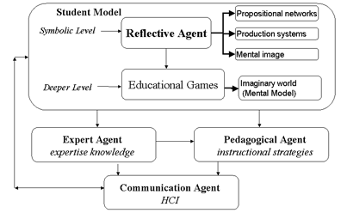
Figure 1: REAL System Architecture

- The REAL implementation

We have designed REAL variants in the domain of ecology (REAL Planet) and probability (REAL Business). We chose these two domains because they required two different kinds of skills to be taught. An ecological system represents a typical complex emergent system that can be better predicted through simulation; while problems on probability can be modeled in a relatively straightforward deterministic system.
In REAL-Business, Students are supposed to help a store owner design business strategies to run an ice cream store. They help a reflective agent through observing the event network, probabilities to multiple events, as well as data from the prior sales. The teaching is done through students’ designing production rules. The outcome is observed in the simulation game. Data are collected, reorganized, and displayed for students so that they can justify and evaluate their predictions based on the simulation and data evaluation.
In Design Mode, students are provided with tools to view entities, such as possible events, as well as relations between entities, such as probabilities of an event happening after a certain condition. Students then complete procedural rules by reasoning about the likelihood of possible events in the game. These facts and rules will guide the reflective agent’s behavior in Game Mode – a simulated real world. Students use the Game Mode to analyze the performance of their agent. Furthermore, students can refer to real-time store reports in Reflection Mode to inspect the results of their teaching.
  - Design Mode

Students are given knowledge contents in the form of tree diagrams. They are like concept maps, or propositional networks, representing declarative knowledge with events and chances that these events occur, given the occurrence of some related event in the game-world.
The best practices of graphical user interface design are considered. For instance, mouse-click and drag-and-drop are applied whenever keyboard typing can be avoided (Figure 2). Images are usually more accurate and vivid ways to present knowledge than text. It would be more intuitive to represent a student’s mental images in their original form. Mental images are a particular type of knowledge representation that exists in human cognition [5]. If relations among objects are visually or spatially grasped, they can help to derive a mental model of a system structure more easily than a textual representation [15, 12]. Therefore, exposing, manipulating and observing externalized mental images can be a valuable and effective way for students to reason about the dynamic processes of the system.
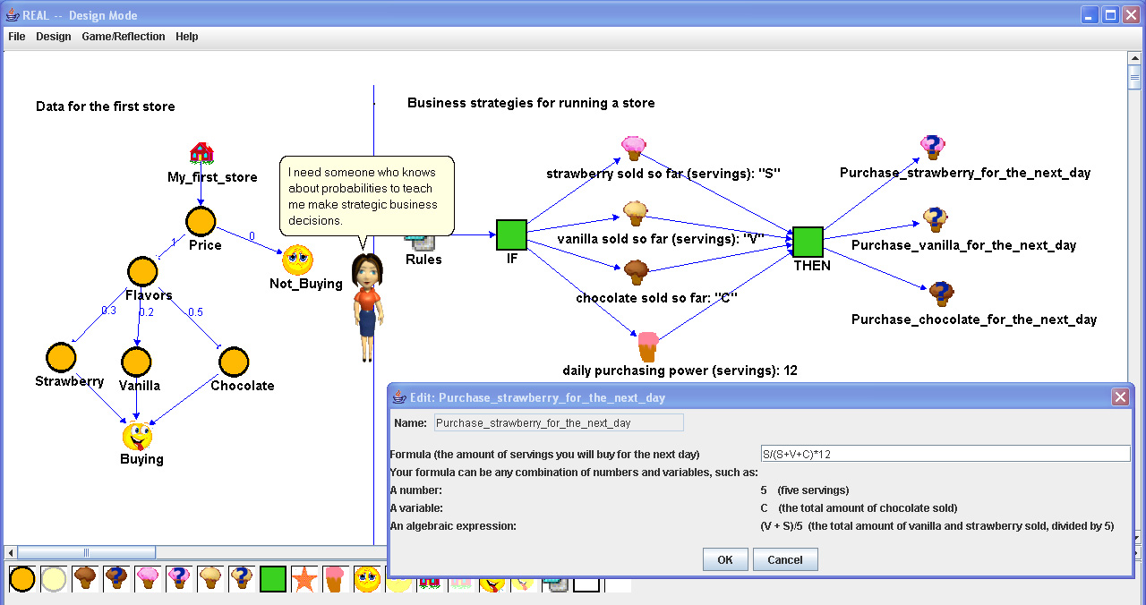
Figure 2: REAL Design Mode (probability tree diagram and production rules)

  - Game Mode & Reflection Mode

The game is generated by applying the game rules taught by students in the Design Mode. The students evaluate how well they have taught the REAL Business reflective agent by observing the agent’s performance running an ice cream store.
Reflection Mode is displayed together with the Game mode in the form of store report (Figure 3). It shows gross profits, product inventories, system networks, and production rules. The learning objective here is to have students make meaningful connections between these various sources of data and the actions in the world, thus gaining better understanding of the system mechanism. If a student’s agent is failing within the game-world, the reflection tools may provide clues for improving the agent. As students’ familiarity with the system grows, we expect them to integrate the various representations of knowledge into a meaningful whole.
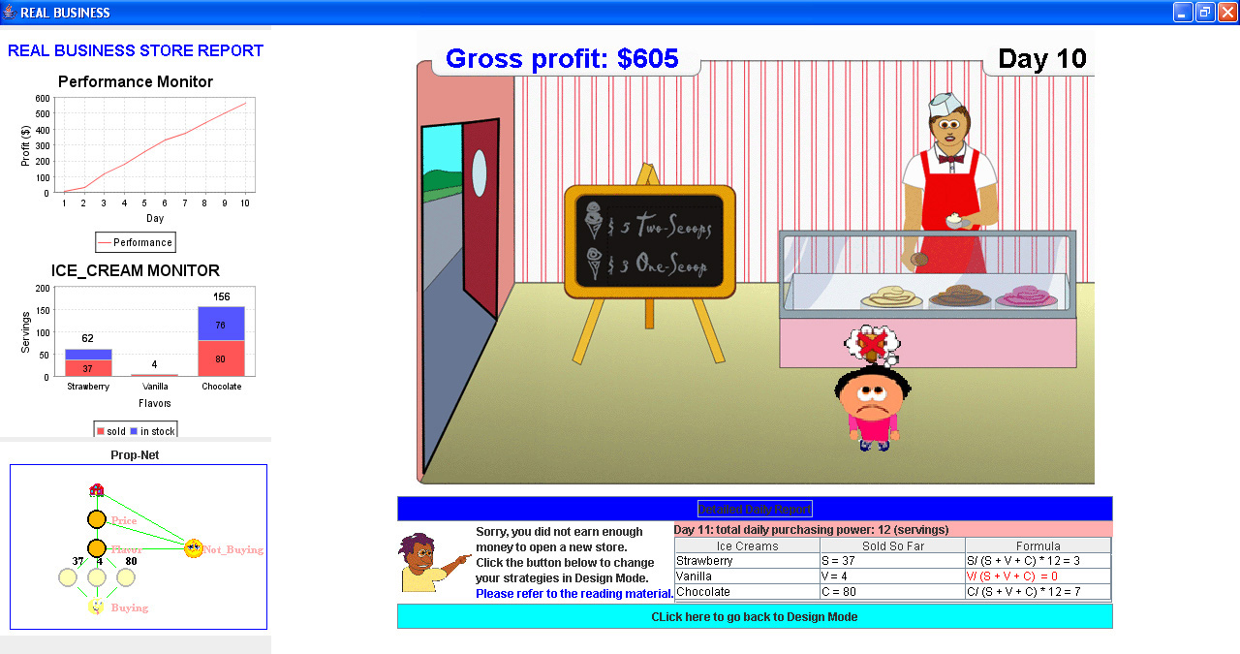
Figure 3: REAL Game Mode & Reflection Mode

- Agent Design

Intelligent agents are embedded in a rule-based system in REAL. A rule-based system consists of facts, rules, and a reasoning engine that acts on them. Facts represent an agent’s goal, belief, desire, physical conditions, etc. Rules represent procedural knowledge, instructing how an agent should act at certain conditions (patterns). Table 1 illustrated an example of how agents were represented as shadow facts in JESS. They were generic active entity that could represent both humans and organisms.

Table 1: Shadow facts of active entities in the REAL platform

f-44 (MAIN::ActiveEntity
(adFlag 0)  (age 2)  (alive TRUE)  (category 0)  (chgImage "")  (class <External-Address:java.lang.Class>)  (communicates FALSE)  (coordinate <External-Address:real.core.Coordinate>)  (costFlag 0)  (currentActivity nil)  (currentSpeed 0)  (description "")  (encounterList <External-Address:real.core.EncounterList>)  (endPoint 0)  (energyLevel 98)  (energyRate 1)  (fatigueLevel 0)  (flavorFlag 0)  (goal nil)  (growthRate 0)  (healRate 0)  (health 0)  (height 8)  (huntForFoodMode FALSE)  (id <External-Address:real.core.Identifier>)  (imageWrapper <External-Address:real.game.ImageWrapper>)  (inDanger FALSE)  (integrityThreshold 0) | (intendtoPay FALSE) (maxAge 99)  (maxSize 0)  (maxSpeed 0)  (minReproductionSize 0)  (minSize 0)  (minSpeed 0)  (name "Customer #453")  (newEncounterStatus 0)  (normalSpeed 0)  (nutrientLevel 78)  (nutrientRate 11)  (obstructs FALSE)  (payStatus FALSE)  (payment 0)  (perceptive FALSE)  (perceptualLimit 0)  (personalSpace 0)  (pointId 0)  (reproduces FALSE)  (reproductionEndAge 0)  (reproductionRate 0)  (reproductionStartAge 0)  (size 0)  (social FALSE)  (type "customer")  (visible TRUE)  (waterLevel 98)  (waterRate 1)  (width 8)  (xSpeed 4)  (ySpeed 0)  (OBJECT <External-Address:real.core.ActiveEntity>))
These shadow facts are observable java objects in the REAL game [Figure 4]. Each object maintains its own status such as age, energy level, preferences, goals etc through a java thread. For instance, in our earlier implementation, REAL Planet, each agent has a thread that autonomously maintains its own basic biological/non-cognitive-related processes such as metabolism, walking, bouncing off obstacles, etc. Each agent has a “biological clock” that starts to tick once the agent is born. The result of the time decay is the decreasing of energy, the increasing of age and size, to name a few. The property status in this lower biology level can affect the agent’s cognitive states. For instance, energy below threshold may cause an agent to pursue a goal of hunting for food. But if the health level is also extremely low, the agent might decide not to take risks getting food that is difficult to obtain. REAL allows students to visualize these changes in Reflection Mode and Game Mode, actively explore relevant information in order to justify their decisions, and explain the mechanisms behind them.
The Jess reasoning engine monitors agents’ status as declarative facts in a virtually parallel fashion. It will trigger events whenever it finds pattern matches in the pre-defined rules residing in the expert module or the student module, thus allowing an agent to sense, reason and act. These agents can decide whether or not to perform an action in a conflict situation according to their goals and beliefs. They are also capable of flexible (reactive, pro-active, social) behaviors [19]. For instance, a customer had the desire to buy ice cream of chocolate flavor, but if that flavor was out of stock, this customer left the store without achieving his or her goal. The store owner identified this situation, and decided to order more ice cream of this flavor for the next day.
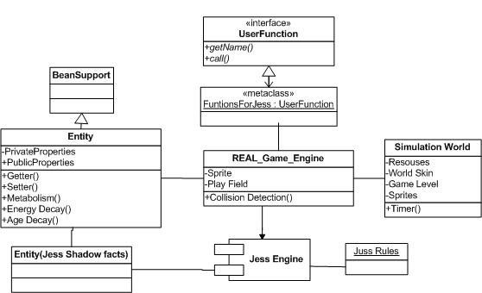
Figure 4: REAL agent architecture

- Study method

We evaluated REAL Business using the internal and external evaluation methods.
The internal evaluation, focusing on internal system performance, addresses the question: “what is the relationship between the REAL cognitive framework and the performance of the REAL application?” More specifically internal evaluation answers the following questions: “What do the reflective agent, expert agent and pedagogical agent know? How do these agents do what they do? What should these agents do?” This is an iterative design process, where we evaluate the advantages and disadvantages using a set of technologies. We looked at ways to standardize our design so that this framework can be developed and deployed to a local context easily.
The external evaluation of REAL aims at the usefulness of the REAL system to the user, such as its ability to foster learning, motivate learns, and encourage scientific exploration. It addresses the questions: “what is the educational impact of REAL?”, “Can REAL increase user’s interest in the related domain?”, “Do users want to learn more about the related domain after playing with REAL?”
The result of the above two evaluations will reveal the educational impact and value of REAL, and will therefore influence the direction for future research and development.
Procedure
We conducted the study in two sessions. Eight students participated in the first session. They worked individually on REAL Business. Four students participated in the second session where they worked in groups of two. We made this change to capture their thinking processes while they exchange their ideas with partners. These are all students from Teacher College at Columbia University.
Students first read the learning material on the targeted domain for 5 minutes. Then they did a pre-test that evaluates the level of their understanding. A reflective agent on the computer screen informed students of the goal of the game. Then our researchers gave a brief orientation on REAL. Students started to design and run the simulation on their own or with their partners. Later, students worked on a post-test, and some participated in a brief interview.
Data source
Data was collected through interviewing with users and researchers. User activity processes were saved in a user’s local computer, and retrieved in xml files after the game. We also captured user interactions with video cameras and voice recorders
Results
Participants mentioned that the simulation was attractive, and the game interface was engaging in both sessions. They said they paid more attention to Game Mode in the beginning. For instance, they paid a lot of attention to thought bubbles in the first several trials, and then they spent more time on observing the charts in Reflection Mode. Later on, they usually adjusted the speed to the maximum, which meant they just wanted to get the general report about a given ice cream store. Students generally had no problem using the tools in Design Mode to teach the agent, although some took some time clicking around nodes or relations to figure out where they should begin.
The students’ ability to successfully complete all levels of REAL Business was mixed. The successful participants orderly used constant numbers, variables, simple expression and complex expressions combined with constants and variables, like S/(V+S+C)*12; while the unsuccessful participant did not make an apparent progress. Some of them were unable to make the conceptual jump from using (concrete) numbers to (abstract) variables. Their strategy proved insufficient because variables could be bound to sales data dynamically, while concrete numbers could not reflect new information that was revealed over the course of the simulation.
The survey results showed student evaluation of REAL on the scale of 1 – 5. Yes/No were used as the scale in the first study session. They were converted as below. As the first session was too short (1 hour), only some students were able to finish the survey.

Table 2: Survey results on REAL Business

QUESTION | MEAN | SCALE | N
Does playing REAL increase your interest in probability? | 4.1 | 1 = strongly disagree  2 = disagree  3 = neutral  4 = agree  5 = strongly agree  4.5 = Yes  1.5 = No | 8
Does REAL give you greater confidence that you can understand and use probabilities? | 3.6 |  | 8
Do you want to learn more about probability? | 4.0 |  | 8

Discussion

The system architecture of REAL was designed with generality and scalability in mind. We finished the prototyping of REAL Business within a couple of weeks. This relatively quick development period allowed us to focus on instructional design before completing our internal and external evaluations. The following accounts for what we learned in the process of development and evaluation, in regards to questions we’ve asked earlier.
What do the reflective agent, expert agent, and pedagogical agent know? How do these agents do what they do? What should these agents do?
In REAL Business, the reflective agent knows about the learning processes that a user undergoes. For instance, it knows how often uses switch from Design Mode to Game Mode, what kind of changes have been made in each step, and what is the user’s understanding about the domain. Later, users will be able to choose different version of reflective agents they’ve built and launch it in the game. The expert agent is able to understand the free-form formulas users provided to teach the reflective agent. It knows how a system functions given a specific community. It is able to give hints when it thinks certain rules are not valid, thus preventing users from advancing to the next game level. The pedagogical agent knows whether and when it should give positive or negative feedback. It will trace rules designed by the user and compare them with rules defined in expert module. If rules are not consistent with those in the expert module, the pedagogical agent will point out the errors in rules, highlighting them in red, instructing users to modify the rules or referring them to more reading material.
REAL is embedded in a rule-based system. It maintains a working memory about the details of the simulation world. While each intelligent agent (customers) walking into the ice cream store, their consuming preferences will be obtained, and their behaviors will be observed by cognitive agents. Patterns matches will trigger rules defined in those cognitive agents to fire, which enable these agents to take actions accordingly.
What each agent should know appears to depend on the specific user. Some users seem to make use of a specific agent while others are likely to disregard the very same information. This aspect of user performance speaks to the need for flexibility within the system. If a user is not utilizing the information of a specific agent the system needs to compensate and adjust to that user. We expect that further developments of REAL will reflect this need for user-based flexibility.
How can we benefit from the agent paradigm and agent-based technologies and apply it to educational simulation games?
We recognize that education is a collaborative endeavor. Our implementation of REAL, using several different agents, recognizes the significance of this collaboration. In order to be successful within the REAL simulation a user must learn how to integrate knowledge from all types of agents into a cohesive whole. This process focuses the user on the type of meta-cognitive thinking that will allow for deeper processing and greater understanding.
Although pedagogical, reflective, and expert agents are not new, our integration of all three agents within an educational simulation is unique. Yet, the non-digital analog of these agents (i.e. teacher, student, and expert source) are certainly a common feature of many educational designs. However, it is not currently within our expectations that we could accurately model the knowledge of a student, teacher, or expert completely. Rather, our attempt is to provide just enough information as to allow the user to successfully accomplish goals and construct appropriate mental models. As we continue to refine REAL and develop new implementations we expect to further our own understanding of the role of each agent in the user’s learning process.

What is the educational impact of REAL? Does playing REAL increase users’ interests in the related domain? Do users want to learn more about the related domain?
Most students did well on pre-test and post-tests. This suggested that they have had some basic knowledge about this domain. Participants in our studies showed great interests to our reflective game. Most of them indicated that the game was very fun and believed that children would love it. Some showed the interest to continue playing with it even after the study. Accordingly to the survey result in Table 2, most participants think REAL had a positive impact on their learning, and they would be interested to learn more in this domain (i.e. probability) in the future.

- Conclusion and future work

From the study on the REAL applications, we found the following values of REAL as a cognitive framework.
1) The learning environment is motivational. Participants in our studies showed great interests in our reflective game. Most of them indicated that the game was very fun and believed that children would love it. Some showed the interest to continue playing with it even after the study. 2) REAL encourages reflection. Most students mentioned that they ran the game in fast speed once they were familiar to the game environment - paying more attention to statistical reports in the Reflection Mode. They actively switched back and forth between Design Mode and Game Mode and made great efforts on improving the knowledge base for the reflective agent. 3) The REAL framework in agent-based approach is reusable and extensible. We had a quick turn-around time in terms of application development in a new domain. The generic agent embedded in a rule-based system hooked up to a game engine can be easily extended for representing humans or organisms. 4) The REAL platform encourages collaboration among researches with interests in such areas as intelligent computer-aided instruction, human computer interaction, cognition, and educational games, to name a few. It can serve as a generic platform for those researches to embed their ideas, and test out their hypothesis.
The broad area REAL covers also exposed its limitations. Most of the time, instructional strategies are domain-specific, therefore, it’s hard to define a generic way to illustrate when and how just-in-time feedback can be delivered to users when they need it. The feedback could include negative, positive, direct, indirect, immediate, delayed feedback, etc. The timing and type of feedback will determine the quality of learning. In the future version, researchers may need to observe and collect the coaching hints and pedagogical information supplied by human tutors during previous studies and build them into the knowledge base of a pedagogical agent. Nevertheless, the REAL framework is designed in such a way that allows developers to add feedback with little efforts.
This study builds a framework for developing intelligent agents in simulation games to encourage active reflection and engage learning. We believe that our system design and implementation of REAL could contribute to the much-needed ongoing efforts of developing intelligent agents for simulation in educational games.

Acknowledgements

The authors would like to thank the REAL team for their contribution to this project. They are Lance Vikaros, Qing Xia, Daoquan Li, Sungbong Kim and Seokmin Kang.

References:
- Anderson, J. R., Boyle, C. F., Corbett, A., & Lewis, M. (1990). Cognitive modeling and intelligent tutoring. Artificial Intelligence, 42, 7-49.
- Bai, X., & Black, J. (2004). TALE: a Teachable Agent Embedded in an Intelligent Tutoring System. In G. Richards (Ed.), Proceedings of World Conference on E-Learning in Corporate, Government, Healthcare, and Higher Education 2004 (pp. 1070-1072). Chesapeake, VA: AACE.
- Biswas, G., Schwartz, D. L., Leelawong, K., Vye, N., & TAG-V. (2005). Learning by teaching: A new paradigm for educational software. Applied Artificial Intelligence, 19(3).
- Black, J. B. (2007). Imaginary Worlds In Gluck, M. A., Anderson, J. R, & Kosslyn, S. M. (Eds.). Memory and Mind: A Festschrift for Gordon H. Bower. New Jersey: Lawrence Erlbaum Associates
- Black, J. B. (1992). Types of Knowledge Representation CCT Report New York:, Teachers College, Columbia University.
- Barsalou, L. W., Solomon, K. O., & Wu, L.-L. (1999). Perceptual simulation in conceptual tasks. In M. K. Hiraga, C. Sinha, & S. Wilcox (Eds.), Cultural, typological, and psychological perspectives in cognitive linguistics: The proceedings of the 4th conference of the International Cognitive Linguistics Association (Vol. 3, pp. 209–228). Amsterdam: John Benjamins.
- Bratman, M. E. [1987] (1999). Intention, Plans, and Practical Reason. CSLI Publications. ISBN 1-57586-192-5.
- Collins, A. M., & Loftus, E. F. (1975). A spreading-activation theory of semantic processing. Psychological Review, 82, 407–428.
- Friedman-Hill, E. (2003). Jess in Action: Rule-Based Systems in Java, Manning Publications.
- Glenberg, A.M., et al. (2004). Activity and imagined activity can enhance young children's reading comprehension. Journal of Educational Psychology, 96(3), 424-436.
- Kintsch, W. (1988). The role of knowledge in discourse comprehension: A construction–integration model. Psychological Review, 95, 163–182.
- Kosslyn, S. (1978). Imagery and internal representation. Hillsdale, NJ, Erlbaum.
- Malone, e. a. (1997). Agents for information sharing and coordination: A history and some reflections. Menlo Park, CA, MIT Press.
- Matrice.com 374 Ch. Vallaja 06440 L'Escarène France
- Rohr, G. (1986). Using visual concepts. New York, Plenum Press.
- Schank, R. C., & Abelson, R. P. (1977). Scripts, plans, goals, and understanding: An inquiry into human knowledge structures. Hillsdale, NJ: Erlbaum.
- Schön, D. (1990). "The theory of inquiry: Dewey's Legacy to education. ." Unpublished manuscript.
- Williams, M. D., Hollan, J.D., & Stevens, A.L. (1983). Human reasoning about a simple physical system. In Gentner, D., & Stevens, A.L. (eds.), Mental Models. Hillsdale, NJ: LEA.
- Wooldridge, M. J., N. (1995), "Intelligent Agents: Theory and Practice". The Knowledge Engineering Review 10 (2), 115-152.

